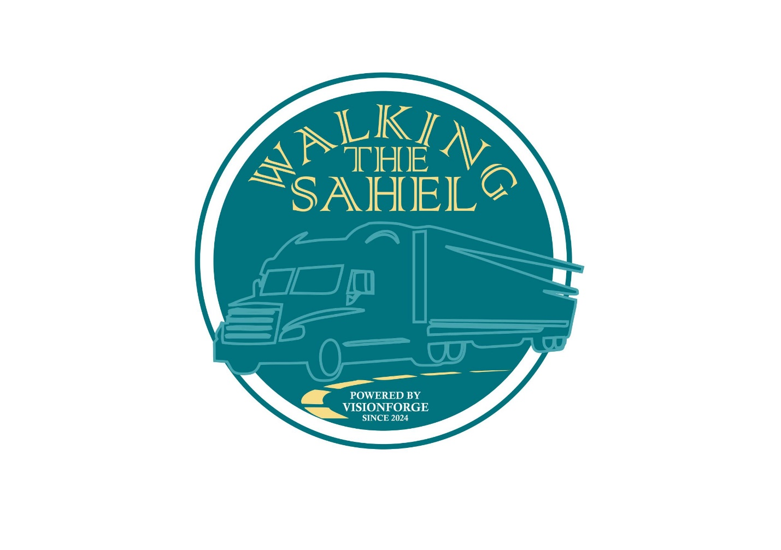

**1. Executive Summary**

**Overview**

*Walking The Sahel (WTS)* is an innovative e-commerce platform designed to revolutionize the sourcing and delivery of raw materials, agricultural produce, and fuel options across the Sahel region of Africa. Our mission is to create a seamless, efficient, and transparent marketplace that connects rural suppliers to urban and international buyers, reducing inefficiencies and fostering economic growth in the region.

**The Problem**

The Sahel region—rich in natural resources—faces significant challenges, including poor infrastructure, limited access to markets, and inefficiencies in supply chains. This has resulted in untapped economic potential, inconsistent product quality, and limited opportunities for small-scale suppliers.

**The Solution**

By leveraging modern technology, *WTS* simplifies access to raw materials, agricultural products, and fuel. The platform provides:

* A user-friendly interface for buyers and suppliers.
* Comprehensive quality assurance systems.
* Real-time tracking and logistics integration.
* Market insights and pricing transparency.

**Our Mission**

To empower local producers and truck owners, promote sustainable trade, and bridge the gap between supply and demand for essential commodities in Africa’s Sahel region.

**Our Vision**

To become the leading e-commerce platform and logistics funnel for raw materials and agriculture in Africa, fostering equitable growth and sustainable development.

**Current Status**

* **Platform Development**: Nearing completion with core functionalities like product listings, order management, and delivery integration ready for deployment.
* **Initial Partnerships**: Established agreements with local suppliers and logistics providers in key regions.
* **Market Interest**: Early surveys indicate high demand for streamlined supply chain solutions.

**Goals**

1. Launch the platform in two key Sahel countries within six months with plans to expand to two others within 18 months.
2. Onboard 1,000 suppliers and 5,000 active buyers within the first year.
3. Achieve $1M in gross merchandise volume (GMV) within 18 months.

**Key Financial Highlights**

* **Revenue Streams**:
  + Transaction commissions.
  + Subscription plans for high-volume users.
  + Premium listings and value-added services.
  + Convenience charges and cost-per-mile for deliveries
* **Funding Requirements**:
  + Seeking $500,000 in seed funding to finalize development, market the platform, and build operational capacity.

**Impact**

* Empower over 10,000 small-scale farmers, miners, and fuel suppliers.
* Facilitate cross-border trade worth millions of dollars annually.
* Contribute to regional economic growth by reducing supply chain bottlenecks and fostering market access.

**2. Business Description**

**Overview**

*Walking the Sahel* is not just an e-commerce platform; it is a transformative ecosystem tailored to the unique challenges and opportunities of the Sahel region. By integrating advanced technology with local realities, *WTS* bridges the gap between suppliers and buyers, ensuring efficiency, transparency, and growth.

**Core Features**

1. **Marketplace Categories**:
   * Solid Minerals
   * Agriculture
   * Building Materials
   * Petrol & Gas
2. **Integrated Logistics**: The delivery system operates similarly to ride-hailing apps, leveraging a network of truck drivers. In the Sahel region, where most truck drivers operate vehicles owned by fleet managers, the platform sends real-time notifications detailing pickup locations, product specifications, and drop-off points. This ensures:
   * Optimal route planning.
   * Reliable delivery services.
   * Real-time updates for buyers and suppliers.
3. **Quality Assurance**:
   * Verified suppliers.
   * Product checks at critical points in the supply chain.
   * User ratings and reviews.

**How It Works**

1. **For Buyers**:
   * Browse products across categories.
   * Place orders with clear delivery expectations.
   * Track orders in real time.
2. **For Suppliers**:
   * List products with detailed descriptions and pricing.
   * Receive instant notifications of new orders.
   * Coordinate with fleet drivers for efficient delivery.
3. **For Drivers**:
   * Accept delivery tasks via the platform.
   * Access detailed instructions on routes, products, and drop-off points.
   * Earn based on completed deliveries, fostering transparency in payments.

**Unique Selling Proposition (USP)**

* **Regional Focus**: Tailored specifically to the Sahel region’s challenges and strengths.
* **Driver-Focused Logistics**: A groundbreaking integration of Uber-like principles into a B2B supply chain context, aligning with local ownership models.
* **Comprehensive Ecosystem**: From sourcing to delivery, *The Sahel* handles the entire value chain.

**Business Model**

The Sahel operates on a B2B model with the following revenue streams:

1. Commissions on successful transactions.
2. Subscription plans for frequent buyers or large suppliers.
3. Fees for premium services like quality testing, priority listings, and data insights.

**Social and Economic Impact**

* **Empowering Local Producers**: Small-scale farmers and miners gain access to larger markets and fair pricing.
* **Streamlined Supply Chains**: Reduces inefficiencies and ensures timely delivery.
* **Economic Growth**: Encourages regional trade, cross-border commerce, and job creation for drivers and logistics operators.

**3. Market Analysis**

**Regional Overview**

The Sahel region spans several African nations, characterized by abundant natural resources and a growing demand for industrial and agricultural commodities. Despite its potential, the region faces significant market inefficiencies due to infrastructure challenges, fragmented supply chains, and limited cross-border trade systems.

**Key Statistics**

* **Market Size**:
  + Agriculture accounts for over 40% of GDP in many Sahelian countries.
  + The mining sector in the Sahel is projected to grow at an annual rate of 6% over the next decade.
  + Fuel demand in West Africa is expected to increase by 30% in the next five years.
* **Challenges**:
  + Over 70% of rural suppliers lack access to consistent buyers.
  + Logistics inefficiencies increase delivery costs by an average of 25%.

**Current Market Challenges**

1. **Fragmentation**:
   * Lack of a unified platform for sourcing and buying raw materials.
   * Heavy reliance on informal trade networks.
2. **Price Volatility**:
   * Inconsistent pricing due to a lack of market transparency.
3. **Limited Logistics Options**:
   * High costs and delays caused by inadequate infrastructure and long supply chains.

**WTS' Solution**

1. **Market Consolidation**:
   * Provides a centralized platform for buyers and suppliers.
   * Reduces dependency on intermediaries, leading to fairer pricing.
2. **Price Transparency**:
   * Offers real-time data on market trends and product pricing.
   * Enables informed decision-making for buyers and suppliers.
3. **Efficient Logistics**:
   * The Uber-like delivery system streamlines transportation, ensuring faster and more reliable deliveries.
   * Integrated tracking minimizes uncertainties in delivery timelines.

**Competitor Landscape**

While there are emerging platforms addressing specific sectors in Africa, few offer the comprehensive, multi-category approach of *Walking* *The Sahel*. Competitors focus primarily on agriculture or logistics separately, leaving a gap for integrated solutions like ours.

**Market Opportunity**

The Sahel's holistic approach positions it to capitalize on:

1. A $10B+ market for agricultural and mineral trade in the Sahel.
2. Rising cross-border trade opportunities under the African Continental Free Trade Area (AfCFTA).
3. Increased digitization of supply chains, creating demand for platforms that streamline sourcing and logistics.

**4. Technology Stack**

**Overview**

The Sahel is powered by cutting-edge technology designed to ensure scalability, reliability, and security. The platform’s architecture supports seamless operations, from user interactions to backend logistics, enabling a smooth user experience for buyers, suppliers, and drivers alike.

**Core Components**

1. **Front-End**:
   * Developed with **React.js**, ensuring a dynamic and responsive user interface.
   * Optimized for accessibility and ease of use across devices.
2. **Back-End**:
   * Built using **Payload CMS** and **Express.js**, offering robust and flexible backend operations.
   * Ensures fast processing of user requests, secure data handling, and seamless integration with third-party services.
3. **Database**:
   * Utilizes **MongoDB**, providing scalable and flexible data storage.
   * Ensures secure and organized management of product listings, user information, and transaction records.
4. **API Integration**:
   * Features **RESTful APIs** for smooth integration with logistics providers, payment gateways, and analytics tools.
   * Enables real-time data synchronization across the platform’s ecosystem.
5. **Cloud Infrastructure**:
   * Hosted on a scalable cloud platform (e.g., AWS, Azure—final selection in progress) to handle high traffic and data demands.
   * Provides disaster recovery, load balancing, and enhanced security.

**User-Focused Design**

The technology stack is designed to accommodate the specific needs of:

* **Buyers**: Intuitive search, order placement, and tracking functionalities.
* **Suppliers**: Easy product listing and inventory management.
* **Drivers**: Real-time delivery updates and route optimization.

**Security Measures**

* **Data Encryption**: Ensures secure transmission of sensitive data, such as payment information.
* **Authentication Protocols**: Multi-factor authentication and secure login processes to protect user accounts.
* **System Monitoring**: 24/7 monitoring to detect and mitigate potential threats.

**Future Enhancements**

1. **AI Integration**:
   * Predictive analytics for market trends and pricing insights.
   * Automated recommendations for buyers based on purchasing history.
2. **Blockchain Technology**:
   * Smart contracts for secure and transparent transactions.
   * Enhanced traceability for raw materials and agricultural products.
3. **Mobile App**:
   * A dedicated mobile app to further streamline user access and engagement.

**Technical Workflow Diagram**

*[Insert a flowchart showing user interactions (buyers, suppliers, drivers) and how requests are processed through the front-end, back-end, and database systems. Include API calls to logistics and payment gateways.]*

**5. Marketing and Advertising Strategy**

**Overview**

To achieve international recognition and attract foreign buyers, *WTS* will deploy a multi-faceted marketing strategy that highlights the platform’s role in promoting African minerals and agricultural produce globally. This approach will not only drive sales but also aid in boosting foreign exchange earnings by connecting African suppliers to a broader international audience.

**Key Objectives**

1. Establish *WTS* as the premier marketplace for African raw materials and produce.
2. Position the platform as a trusted source of high-quality products with transparent sourcing practices.
3. Increase international buyer engagement to drive cross-border trade.

**Core Strategies**

1. **Global Digital Campaigns**:
   * Launch targeted ads on platforms like Google, LinkedIn, and Facebook to reach industrial buyers, exporters, and wholesalers in Europe, Asia, and North America.
   * Highlight the platform’s transparency, ease of use, and secure supply chain.
   * Use geo-targeted campaigns to focus on countries with high demand for African commodities.
2. **Content Marketing**:
   * Develop a blog and video series showcasing success stories of suppliers and buyers using *WTS*.
   * Highlight the ethical sourcing practices and the social impact of buying African products.
   * Publish white papers and reports on African trade opportunities.
3. **Trade Fairs and Expos**:
   * Participate in international trade fairs, such as the World Trade Expo and the Global Agricultural Summit.
   * Set up interactive booths to demo the platform and network with potential buyers.
   * Distribute promotional materials emphasizing *The Sahel*'s unique value.
4. **Partnerships with Export Bodies**:
   * Collaborate with African export organizations and chambers of commerce to amplify reach.
   * Leverage their networks to build trust with foreign buyers.
5. **Influencer and B2B Outreach**:
   * Partner with industry influencers and supply chain experts to promote *WTS*.
   * Conduct webinars for B2B buyers, highlighting the platform’s benefits.

**Advertising Channels**

1. **Social Media Advertising**:
   * Run sponsored campaigns on platforms like Instagram, Twitter, and LinkedIn, targeting procurement managers and importers.
   * Use engaging visuals and testimonials to increase clicks.
2. **Email Campaigns**:
   * Create personalized email funnels targeting potential buyers based on their industry and location.
   * Highlight product availability, special offers, and platform benefits.
3. **Search Engine Optimization (SEO)**:
   * Optimize the platform for keywords related to African minerals and agriculture to improve search rankings.
   * Use localized SEO strategies for specific target markets.
4. **Pay-Per-Click (PPC) Ads**:
   * Focus PPC campaigns on high-conversion keywords like "buy African raw materials" or "sustainable agricultural suppliers."

**Key Metrics**

1. Website traffic from international regions.
2. Conversion rates from marketing campaigns.
3. Volume of inquiries and orders from foreign buyers.
4. Growth in foreign exchange revenue.

**Promotional Diagram**

*[Insert a diagram showing the flow of international marketing efforts, from digital campaigns to trade fairs and buyer conversions. Highlight feedback loops for optimizing strategies.]*